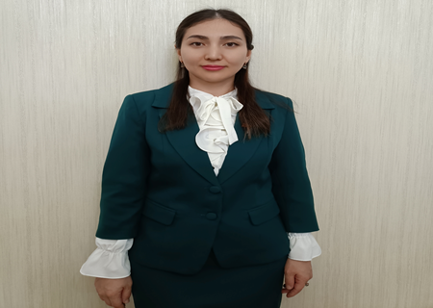

**900913401660**

**ТАСТАНБЕКОВА Бактыгул,**

**М.Мәметова атындағы №33 жалпы білім беретін мектебінің**

**ағылшын тілі пәні мұғалімі.**

**Түркістан облысы, Жетісай ауданы**

**WEATHER 1**

|  |  |  |  |  |  |
| --- | --- | --- | --- | --- | --- |
| **Learning objectives** | | 4.L9 recognise words that are spelt out from a limited rung of general and curricular topics  4.W5 link with some support sentences using basic coordinating connectors  4.UE16 use conjunctions and, or, but, because to link words and phrases | | | |
| **Lesson objectives** | | **All learners will be able to**:  Do reading tasks with support;  Fill in the gaps with 80% of correct words in writing task;  Answer the questions giving a short answer;  **Most learners will be able to**:  Do reading tasks without support;  Fill in the gaps with 90% of correct words in writing task;  Give a full answer to the questions;  **Some learners will be able to**:  Do reading tasks independently and support other ss;  Fill in the gaps with 100% of correct words in writing task;  Give an extended answer to the question; | | | |
| **Criteria** | | Learners will need to be familiar with/Structures: comparisons; the verb 'have got'; there is/are. | | | |
| **Previous learning** | | Weather 1 | | | |
| **Plan** | | | | | |
| **Planned timings** | **Planned activities** | | **Learners’ activities** | **Evaluation** | **Resources** | |
| **Begining**  **5 min** | GREETINGS. INTRODUCE THE LESSON OBJECTIVES.  Teacher greets learners and asks questions about the day, date and the weather  Have learners write the date and topic of the lesson.  Draw learners’ attention to the lesson objectives and make sure they all understand them. | | Greeting |  | White board/ markers | |
| **Middle**  **30 min** | **Pre-learning activities:**  Teacher divides the class into 2-3 groups, hands in a sheet of blank paper and asks them draw a mind map with the weather words they know from their prior learning.  Ask groups present their findings before the class and compare their knowledge of words. Whole class discussion.  **vYQvlEp7330**  **Listening and writing practice**  Ask learners make two columns in copybooks and write two headings “Country” and “Weather”. For listening practice.. Video is played 3rd time for learners to check.  **Match the words to the pictures. Then listen and check?**  Pupils' books closed. Put up the Camping poster on the board. Point to the items, one at a time, and say the corresponding words. The pupils repeat, chorally and/or individually. Point to each item in random order. Ask individual pupils to name them.  Pupils' books open. Play the CD. The pupils listen and repeat. If you wish, play the CD again pausing after each word.The pupils repeat, chorally and/or individually.  Allow the pupils some time to complete the activity.Then they listen again and check their answers. | | Learners follow the instructions  Learners swap copybooks and peer check each other  Leasrners match the words to the pictures, then listen and check  Learners read the words and match them to the pictures. | Verbal evaluation  Individual avaluation  Mutual avaluatio | A blank sheet of paper, magnets, white board. | |
| **End**  **5 min** | REFLECTION  What have you learnt today? Name the words you learnt.  What task was easy and hard for you?  Home task: Ex: 1 at page 48  **Saying goodbye** | |  | Self-assess-ment |  | |